Settings for publications

- Search for “Region settings”
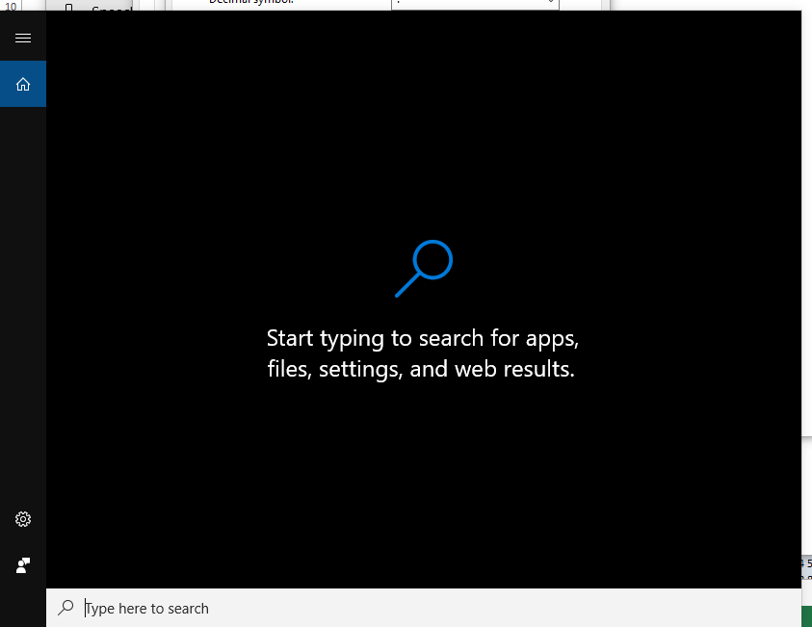

- In the top right side, click on “Additional date, time & region settings”
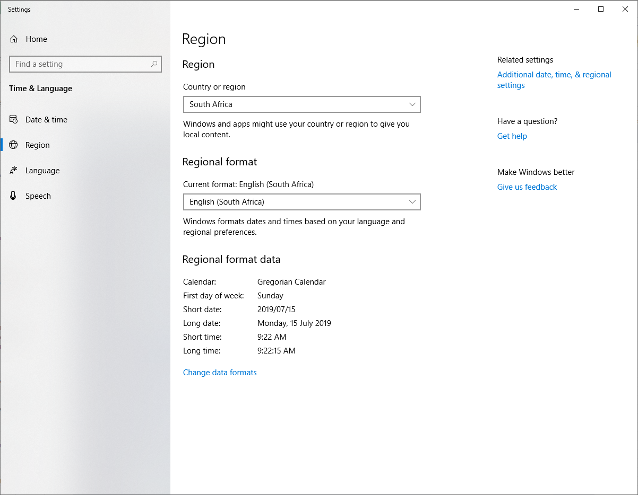

- Click on “Region”
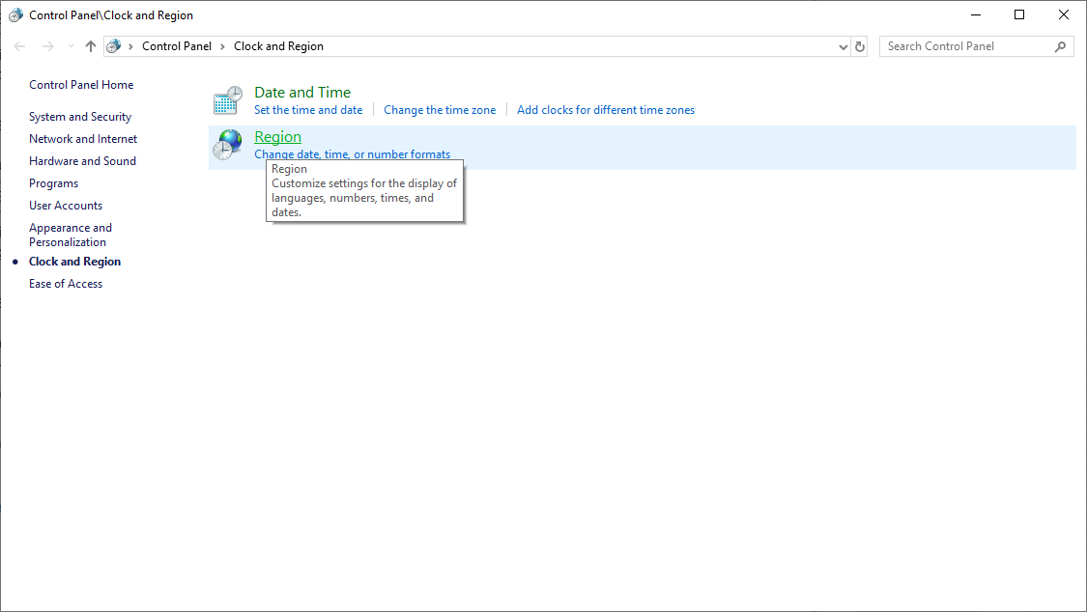

- Click on “Additional settings…”
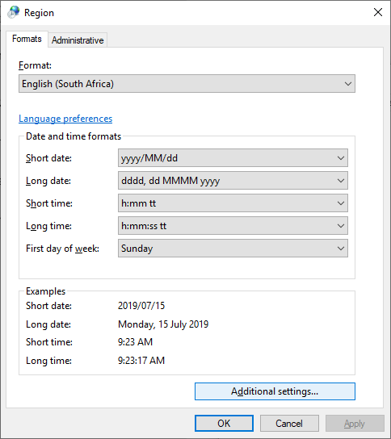

- Input the settings as displayed below
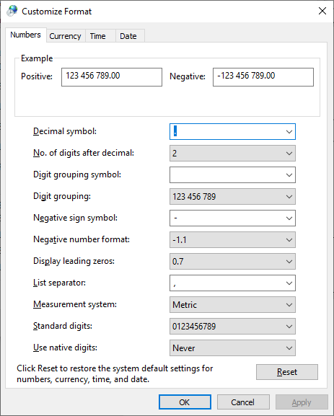

Decimal symbol: Full stop (“.”)
Negative sign symbol: Minus (-)
Digit grouping symbol: One space ( )

